Useful phrase:

We can access the individual character in a string through **indexing**.

Notice: what you use the input, **it is always a str**. If you want other type of data, you can convert then.

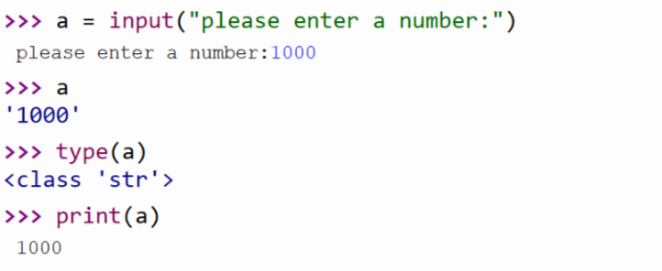

Watch out the type !!!

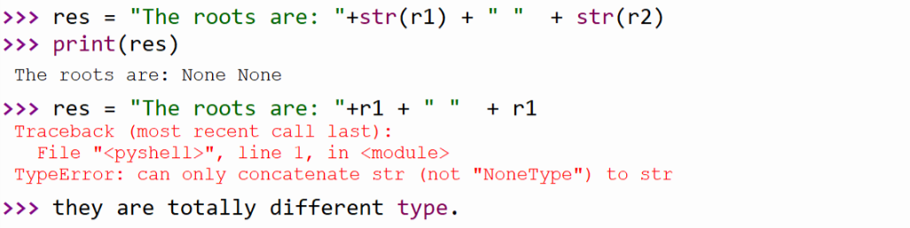

**如果不加“\n”，那the roots are… 只会不停地继续下去而不会换行**

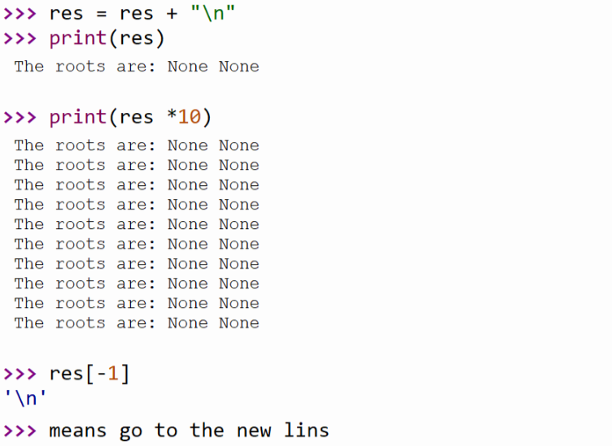

当要循环把res中的characters print出来的时候，可用下列方法，

（print本身就是一个换行的意思）

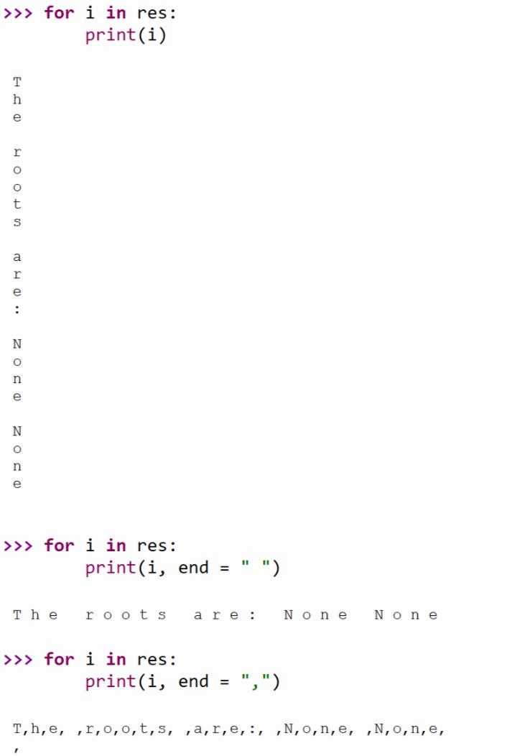

The contiguous sequence of characters is called **substring**, which can be done through a process called **slicing**.

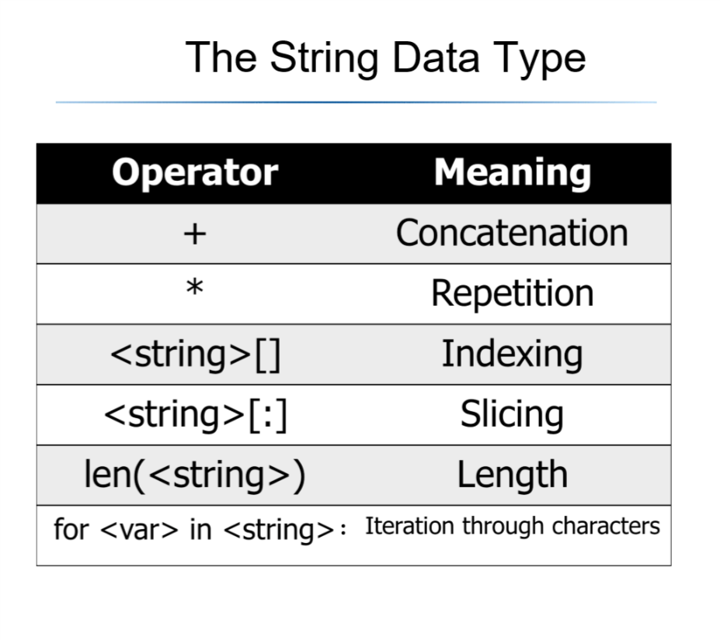

Once you create a string, you can add a . and press **the tab hit** to use **the string library**.

**The ord function returns the numeric/ordinal code of a single character.**

**The chr function returns converts a numeric code to the corresponding character.**

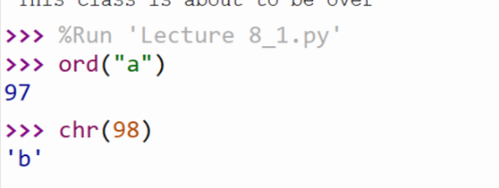

**Encryption:**

The process of encoding information for the purpose of keeping it secret or transmitting it privately is called encryption.

More string methods:

Str () -> return a string representation

s. capitalize () -> Copy of s with only the first character capitalized

s. title () -> Copy of s; first character of each word capitalized

s. center (width) -> Center s in a field of given width

s. count (sub) -> count the number of occurrences of sub in s

s. find (sub) -> find the first position where sub occurs in s

s. join (list) -> concatenate list of strings into one large string

s concatenates the elements in the list